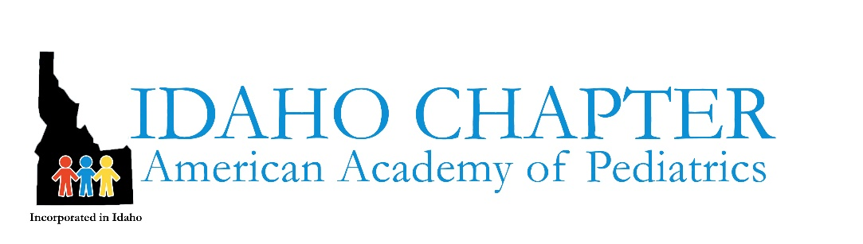

Dear Chapter Colleagues,
The AAP Board and CEO are empowering pediatricians to use the AAP policy statement, The Effects of Armed Conflict on Children, to advocate within our own communities – and with elected officials – to take the actions needed to protect children and families who are suffering in Israel/Palestine.
Pediatric advocacy can include:
- Contacting and/or meeting with elected officials
- Writing op-eds or letters and/or contacting media
- Partnering with others
- Working with your own organizations to encourage advocacy or lobbying at the highest levels
- Talking to your local community leaders
- Organizing awareness campaigns
- Remembering you are speaking as yourself, not representing the chapter.
Talking points from the AAP policy statement with the November 2023 updates include:
- Children should never be harmed because of religious, cultural, and other beliefs and values of the child and/or their family.
- Harm to children should never be used as a tool or tactic of war or conflict.
- Children should be protected from the direct effects of armed conflicts and their food, housing, health and other basic needs should be safeguarded.
Our hope and prayers are with all children and their families who are impacted with this suffering.

Idaho AAP Leadership

